GS 104 Wind Turbine Analysis Worksheet:

In David MacKay's book he has talked about wind energy from a large scale perspective. He developed useful numbers to think about based on average wind speed and the amount of land area that you could use to generate wind energy. This gives us a way to think about how wind might help meet the needs of our national community.

A different question that is of interest to many people is whether wind energy is a reasonable choice for each of us individually. This worksheet is my attempt to help you understand how you would figure that out for yourself.

The two primary sources of information we will need are the wind rose data for the area of interest and the power curve for the particular wind turbine in question.

Step I) Extracting the relevant data from the wind rose.

Total Hours in Month of April:________________

The wind speed is the average speed for each zone in the wind rose. The standard height for wind speeds gathered for weather is 10 m which is what we are considering.

Determine the percentage of each zone (wind speed) of the "flag" and then add together all the percentages for each zone to get total percent of the month that the wind is blowing a particular average speed.

wind speed range | percent of month | number of hours (% x hrs)

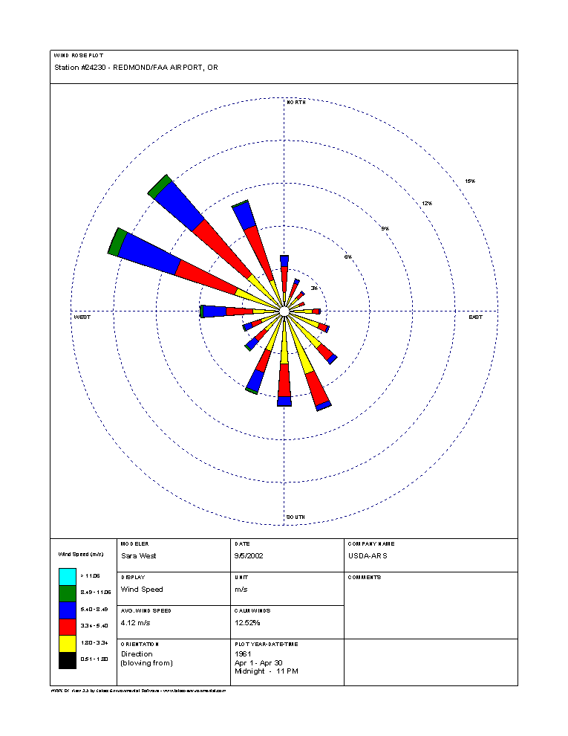

Step 2) Decoding the power curve:

Pick a wind speed that matches the average wind speeds from your previous table. Determine the rate at which energy is generated (power = Watts = W) at that speed. Use the plot on the last sheet of this worksheet to find this.

The kWh generated is the rate of power generation times the number of hours (from previous table) that the wind is blowing that speed.

Wind Speed (average) | Power Generation (PG) | hrs at that speed from prev table | kWh Generated (hrs x PG)
 |  | Total Energy Generated

Step 3) Economics:

Let's continue to assume that each kWh is worth about $0.10. The Aeolos-H 500W is about $1000 with a simple 10 m tower.

What is the value of the energy generated in April?

If the other months were much the same what would be the value of the energy generated over a year?

How long (in years) will it take before the wind turbine pays for itself and how long is it expected to last?

How much energy/$$ would I lose if I turned my wind turbine off when the wind was < 5 m/s?

Power Generation Plots:

