Remote Spectra Lab: Worksheet
Name:
Date:

1: Do you identify the spectra from the incandescent bulb as a bright line, dark line, or continuous spectra? What is the wavelength in nm of the yellow light indicated by the arrow?

2: Bright Line Spectrum for Hydrogen
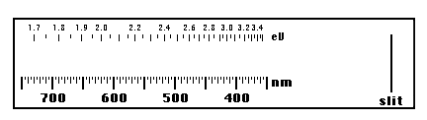
3: Bright Line Spectrum for Neon
4: Bright Line Spectrum for Nitrogen
5: Bright Line Spectrum for Mercury

6: Which element has the 'simplest' spectrum and which is/are the most complicated? Look up each element on the periodic table and see what it's 'number' is. Is there a correlation between the atomic number and the complexity of the spectra? Nitrogen is more complex because it is actually a molecule of N2 which has more options than N alone.

7: Sketch the bright lines from the spectrum for the fluorescent light. Do the bright lines match up with any of the earlier spectra? What does the continuous portion of the spectrum suggest?

8: What is your analysis of the spectrum from the LED? Are there bright lines? How does it compare with the spectrum of the incandescent bulb?

