Programming the Quadratic Formula into the TI-83+
For those times when a numeric approximation to the solution of a quadratic equation will suffice, using a programmable calculator to automatically compute and simplify the quadratic formula is rather convenient. Since we shall expand upon the programmable features of the TI-83+ throughout the course this is a good starting point.  = ENTER

COMMAND | COMMENTS
Press PRGM | Brings up the Program Menu: EXEC EDIT NEW
Select NEW  | Use EDIT to edit an existing program
Name=QF  | Names the program QF. Other names will also suffice.
:ClrHome  | PRGM → I/O → 8. Clears the home screen.
:a+bi  | MODE → a+bi. Sets the TI-83+ to Complex mode.
:Disp "SOLVES"  | PRGM → I/O → 3. Screen message.
:Disp "Ax² + Bx + C = 0"  | PRGM → I/O → 3. Screen message. Use 2nd TEST for '='
:Prompt A,B,C  | PRGM → I/O → 2. Will prompt the user for A, B and C
:(-B+√(B²−4AC))/(2A)åP  | Calculates the first root and stores it in P. å= STOå
:Disp P  | PRGM → I/O → 3. Displays the first root.
:(-B−√(B²−4AC))/(2A)åQ  | Calculates the second root and stores it in Q. å= STOå
:Disp Q  | PRGM → I/O → 3. Displays the second root.
:Real  | MODE → Real. Resets the TI-83+ to Real mode.

Now let's run the program. Use PGRM → EXEC → Select Program . Note: For these examples the MODE was preset to 2 decimal accuracy.

Example 1 Solve x² + 2x + 2 = 0
We identify A = 1, B = 2 and C = 2.  PGRM → EXEC → QF  | 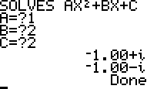 | actual solutions  x = -1 ±

Note: Pressing ENTER at the conclusion of a program will rerun a fresh version of the program.

Example 2 Solve x² + 5x = 6
Rewrite in Standard Form: x² + 5x − 6 = 0  We identify A = 1, B = 5 and C = -6.  PGRM → EXEC → QF  | 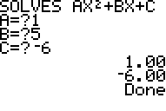 | actual solutions  x = 1 or -6

Example 3 (one double root): Solve 9x² − 12x + 4
We identify A = 9, B = -12 and C = 4.  PGRM → EXEC → QF  | 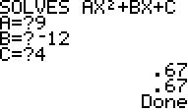 | actual solutions  x = 2/3
Example 3a
We can use the built in fraction feature of the TI 83+ to convert solutions to a rational number (if possible). Since the answers remain in P and Q for later use we can try to convert them to a fraction. | MATH → åFrac   | 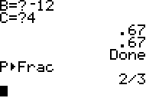

Example 4 (a tricky one): Solve x² − 2x + 2 = 0
We identify A = 1, B = -2 and C = 2.  PGRM → EXEC → QF  | 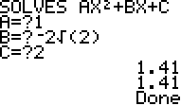 | Note: These solutions are irrational and cannot be converted to rationals.  actual solution x =

Now solve these problems. Write down rational solutions where appropriate. Be sure to work some by hand.

1) x² + 11 = 6x | 2) 6(2x² + 1) = 17x
3) 9x² + 1 = 5x | 4) 5x(5x − 14) = -7²
5) 3x² + 1 = 4x | 6) 2(x² + 2) = -1
7) 4(x + 1)² − 4(x + 1) = 3 | 8) 3x² + 2 = (5x − 4)² − 5(x − 3)
9) 4x² + 1 = | 10) (t² − 5t)² + 2(t² − 5t) − 24 = 0
 | Hint: Let t² − 5t = x.

