Math 95 Fall 2012
Naffziger Lab #3

The purpose of this lab is to introduce you to the graphing capabilities of your calculator. The lab is written with the TI-82, 83, 83+, 84 in mind. The other TI calculators are similar, but there are some differences. I strongly urge you to read and work along with the first 3 pages of this lab before you start the problems.

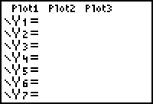
- To graph a function you must press the [ Y= ] key. Once there you will see that you can input many different functions.
The "Plots" will be used later

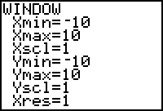
- Once you have entered your function you will want to use [Window] key. This will allow you to get the part of the graph you want to look at.
Xmin and Xmax represent the smallest and largest x-values
Xscl determines the interval between tic marks on the x-axis.

Ymin, Ymax, and Yscl do the same thing on the y-axis.
- The [Zoom] key enables you to zoom-in as well as zoom-out on any part of the graph. The default setting of [-10, 10] for the x- and y-axes is accomplished with a keystroke of [Zoom] [ 6 ].

- The [Trace] key allows you to move along a graph with the x- and y-coordinates displayed as you travel along the graph. To move the cursor you simply push the left or right arrow. Pushing the up and/or down arrow will move the cursor to another graph. Of course this only applies if you are graphing more than one function.
- The [Graph] key sends a message to the calculator that you are ready to see the graph. The calculator graphs everything in the [ Y= ] menu on the domain and range you specified in the [Window] menu.

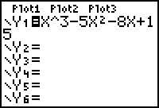
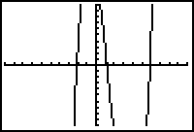
- Here is an example of a typical sequence of windows
- The picture below is the same graph, but I changed the Ymin, Ymax, and Yscl values. Change yours so that your calculator matches mine.
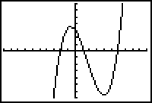
Hint: The Yscl is 5.

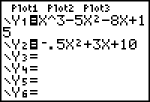
- To graph another function, you simply go back to [ Y= ] and type in the function.
Leave the same [Window] and graph these two functions.

- Once you have Y₁ and Y₂ graphed push the [Trace] button. Push the left, right, up, and down arrows until you understand what these buttons do.

- If you need to get a closer look at part of a graph you can use one of the [Zoom] features. Here is an example of the [Zoom] [Box] feature. To see if Y₁ and Y₂ have the same x-intercept near x = -2 hit the [Zoom] key and then select 1:Zbox. You'll see a little "plus" sign floating somewhere on your screen. Place it above and to the left of our point of interest by using the arrow keys. Do they have the
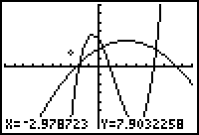
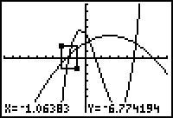
same x-intercept?
Move your cursor to about here, then hit [Enter]
Then move the cursor to the right and below our point of interest and hit [Enter]
Once you hit [Enter], the little box becomes the entire graph. This automatically changes your [Window] settings. What are they now?

- A very powerful and useful menu in your calculator is above the [TRACE] key. It is usually just called [2nd] [Calc]. Among other applications we can use this menu to find x-intercepts, local minimums, local maximums, and where two functions intersect.

- To find the local maximum on the graph of y = x³ – x² – 6x + 4 we would see the following windows. First of all type the above formula into Y1, then set up your window to the standard setting. This can be done quickly by hitting [Zoom] [6]. Once you have your graph, push [2nd] [Calc], then choose maximum.

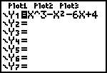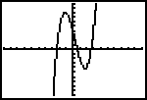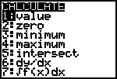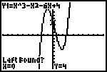

- At this point the calculator is asking you if you are to the left of what you are looking for. Since we are not, we simply move the cursor to the left until we are to the left of what we are looking for (Simply hit the left arrow). Once there we hit [Enter], then the calculator wants us to move to the right of the maximum. Hitting the right arrow until we are to the right of the maximum does this. The last step is to hit [Enter] again to make the calculator start looking for the maximum.
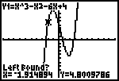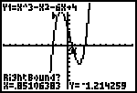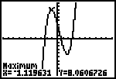

- So we get that the local maximum occurs at the point (-1.12, 8.06). The minimum and x-intercept is done in a similar fashion. To find the x-intercept you choose the “Zero” option inside the [2nd] [Calc] menu.

- To find an intersection between two graphs we select the intersection option. Here is the sequence of windows we would see to find an intersection point between the graph above and the line y = 2x – 3. The first step is to type y = 2x – 3 into Y2, then select the “intersection” option inside the [2nd] [Calc] menu. The calculator will ask you if you are on the first curve, hit [Enter] to accept this graph. The calculator will automatically switch to the other graph. To accept this graph hit [Enter] again. Then move the cursor close to the point of intersection you want and hit [Enter]. The calculator will then find that point of intersection.

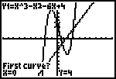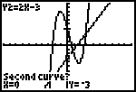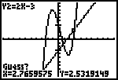
Notice I moved the cursor close to this intersection point.

PROBLEMS FOR LAB #3

When graphing functions on your calculator it is usually a good idea to start with the default settings for the [Window] menu. Recall that this can be done quickly by using the keystrokes [Zoom] [ 6 ]

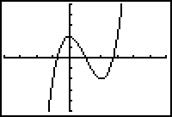
- Graph f(x) = x³ - 3x² + 2. Adjust your [Window] settings to match the graph that is shown. What are the settings for Xmin, Xmax, Xscl, Ymax, Ymin, and Yscl?
Hint→ Just counting the tic mark will help.

- Find the intersection of y = 2x – 3 and y = -x + 9

- Find the intersection of 2x + 4y = 3 and y = 4x + 3

- Find the intersection of 2x + y = 3 and 3y = -6x + 5

- Find the intersection points for the graphs of y = 2x – 3 and y = x³ – 2x² – 3x + 4.

- Find the coordinates for the local maximum and local minimum for the graph of y = x³ + x² – 3x – 7.

- Find the x-intercept for the graph in number 6.

- Use the "Maximum" feature of your calculator to find the vertex of the parabola given by y = -1.4x² + 9.6x + 1

