In – Class Quiz (if you’d like): Center, Variation, and Facebook

In 1991, a sociologist named Scott Feld published the article, “Why Your Friends Have More Friends Than You Do” (). It’s pretty fascinating reading! More recently, the Washington Post released a Facebook – centric version, “Your Facebook Friends Have More Friends Than You.” The gist of both is similar – you (“you” meaning the “typical” person) tend to be friends with people who are more “popular” (as measured by “friendships”) then they themselves are.

After reading this, I wanted to test this hypothesis myself! So, I got onto my Facebook account, selected my friend list, and then drew a random sample from this list. From that random sample, I analyzed how many friends my friends have. Here’s what I got:

Friends My Friends Have

108 | 246 | 438 | 290 | 503 | 257 | 30 | 488 | 697 | 212
296 | 134 | 493 | 184 | 495 | 111 | 145 | 944 | 120 | 1938
2000 | 12 | 225 | 979 | 348 | 5 | 415 | 1946 | 1123 | 144
941 | 489 | 277 | 445 | 239 | 472 | 1507 | 556 | 969 | 338
234 | 180 | 850 | 870 | 110 | 13 | 280 | 296 | 397 | 520
7 | 984 | 45 | 228 | 362 | 80 | 463 | 177 | 306 | 249

(1 point) Find the sample average of these values.

(1 point) Find the sample standard deviation of these values.

(2 points) Take a look at the histogram of the data, and list one reason you might not want to talk about the average and/or standard deviation with respect to this data.

Good! I ran the “=skew(“ command in Excel on these data, and found a skewness value (SV) of 1.88 (a SV of 0 means perfectly bell shaped). Using this table:

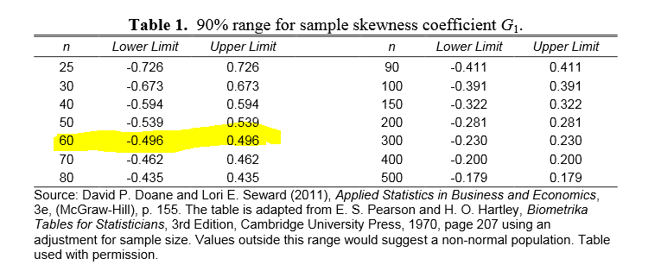

…we can see that the SV we got is outside the “acceptable skewness range” for a bell curve. So, yup – let’s not use averages!

(1 point) Let’s attack this a different (and simpler) way: I have 673 Facebook friends in total (as of 1.26.14). What percentage of friends in my sample above have more than 673 friends themselves (to the nearest whole percent)? Let’s call this “p” for “percentage.”

Let’s use that percentage to calculate the margin of error (MOE) for this study. The MOE is an inferential “2 standard deviation” measure for proportions – we’ll study it more in MTH 244, should you take that journey with us. As you might recall, the MOE adjusts the sample statistic that you collect into a range of values, between which the parameter that you want to study most likely lies.

The formula for a MOE, in this case, is

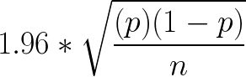

(1 point) Calculate the value of the MOE by using your value from part 4 (and the fact that there are 60 data points). Also – use the decimal form of your answer in part 4.

Now…I’d like to know the population percentage of my friends who have more friends that I do. Let’s see how our random sample did…

(1 point for each grayed blank) Apply the MOE from above to complete the following sentence:

The percentage of Sean’s Facebook friends who have more friends than he does is at least and at most .

(1 point) If you look at all of my friends’ friends (i.e., the entire population), you’ll see that about 24% of them have more friends than I do. Is that parameter value (24%) within the interval you created above? Circle one: YES NO

(1 points) Why must the MOE be attached to the sample proportion?

Go ahead and submit to BB!

http://www.jstor.org/stable/2781907
http://www.washingtonpost.com/business/technology/your-facebook-friends-have-more-friends-than-you/2012/02/03/gIQAuNUlmQ_story.html
There’s actually more to it than just that – I encourage you to check out the reading!
Some of you might say, “Sean! You know how many friends you have, and Facebook tells you how many friends each of those friends has! Why do a sample?” Good question! My answer is twofold: 1) to demonstrate the power of a random sample to you, one that we can test against a known value, and 2) to reiterate, once again, the importance of a MOE (for, in reality, you’re NOT going to have the whole population at your disposal – except in specialized, somewhat contrived situations like this).

