Data Sheet for MTH 244
- Suppose 12% of people normally get the flu during flu season. To test their new flu vaccine, researchers give the vaccine to 1000 people. Of these, 101 got the flu.

- The drug Prevnar is a vaccine meant to prevent meningitis. It is typically administered to infants. In clinical trials, the vaccine was administered to 710 randomly sampled infants between 12 and 15 months of age. Of the 710 infants, 121 experienced a loss of appetite (general population of infants’ loss of appetite: 13.5%).

The Gainesville Sun on reinstating the Florida motorcycle helmet law:

“Florida once had a mandatory helmet law for motorcycle riders. But then - Gov. Jeb Bush and the Legislature decided that courting brain damage ought to be a matter of ‘personal freedom’ and repealed it”
(paraphrased) It was a fatal decision. From 1999 to 2009, the number of deaths from motorcycle accidents has grown in record numbers. In 2009, 402 motorcycle-related deaths occurred here.”
Note: in 1999, the “Florida motorbike death rate” in 1999 was about 0.000745. In 2009, the number of motorbikes on the road was around 590,000 (source: Florida Department of Highway Safety and Motor Vehicles)

- IQ tests are designed to have a mean of 100. We test the IQ of acute head trauma sufferers who, on previous IQ tests, had averaged 100.
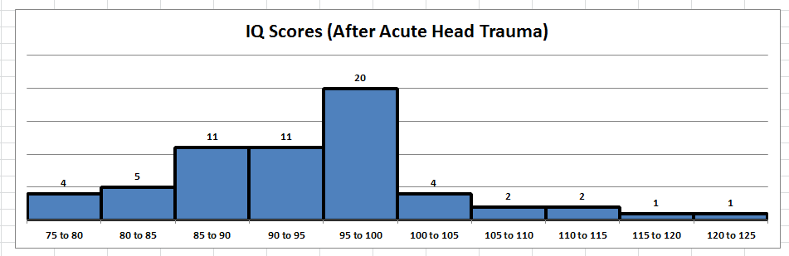
- Below are two data sets showing speeds along a certain road. A neighbor along the road was worried that cars were exceeding the 30 mph speed limit in his neighborhood. He collected some data, as did police:

Individual’s Data |  |  | Police Data
Speed (mph) | f |  | Speed (mph) | f
15 to 20 | 5 |  | 15 to 20 | 1
20 to 25 | 9 |  | 20 to 25 | 3
25 to 30 | 11 |  | 25 to 30 | 2
30 to 35 | 30 |  | 30 to 35 | 4
35 to 40 | 27 |  | 35 to 40 | 4
40 to 45 | 0 |  | 40 to 45 | 0
45 to 50 | 1 |  | 45 to 50 | 1

- A study (reference lost) analyzed peak decibel levels of randomly selected TV shows, and the corresponding peak decibel levels of the commercials immediately following them. Here are the results:
Show | 73 | 73 | 72 | 72 | 69 | 71 | 71 | 71 | 71 | 72 | 73 | 73 | 72 | 72 | 72 | 72 | 73 | 72 | 74 | 72 | 72 | 71 | 70
Commercial | 75 | 74 | 75 | 72 | 67 | 74 | 69 | 72 | 72 | 72 | 74 | 70 | 70 | 73 | 72 | 73 | 74 | 72 | 73 | 73 | 74 | 74 | 68

“Power Balance or Power of Persuasion?” (http://www.acefitness.org/certifiednewsarticle/1261/power-balance-or-power-of-persuasion)

“To test Power Balance’s claims, ACE tapped a team of exercise scientists from the University of Wisconsin, La Crosse Exercise and Health Program, led by John Porcari, Ph.D., and Hazuga. Together they recruited 42 college-aged volunteers, roughly half men and half women, all of whom were NCAA Division III athletes.”
“For one trial, subjects wore a Power Balance bracelet ($30) and for the other trial they wore a placebo ($0.30 rubber bracelet). The order of bracelets worn was completely randomized and double-blinded so that neither the subjects nor the examiners knew which bracelet was being worn for which trial. Half of the subjects wore the Power Balance bracelet for their first trial while the other half wore the placebo bracelet for the first trial.”

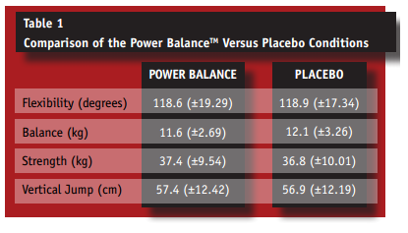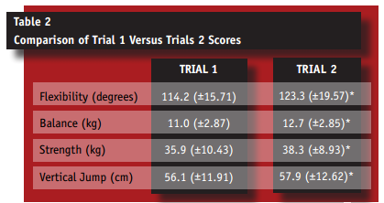

- Do children diagnosed with ADHD (Attention Deficit Hyperactivity Disorder) have smaller brain volume than those without ADHD? According to a 2002 AMA study, the following data were recorded:
 | n | (ml) | s (ml)
ADHD | 152 | 1059.4 | 117.5
No ADHD | 139 | 1104.5 | 111.3

- Core Plus Mathematics is an NSF funded high school mathematics curriculum used in some schools around the country. It strives to use a contextual approach to math, where students focus more on problem solving and less on rote mechanics. In Effects of standards-based mathematics education: A study of the Core-Plus Mathematics Project algebra and functions strand in the Journal for Research in Mathematics Education (31 (2000), 328–361), the authors studied performance of two groups of algebra I students. One group had been taught algebra using the Core Plus Mathematics Program, a problem - solving curriculum for algebra, and the other had been taught algebra traditionally. Students were tested two ways: in one, calculators were not allowed, and in the other, they were.

test scores of Core Plus Math project students vs. Traditional students  (no calculators)  Test score CPMP Control  5 to 10 1 0  10 to 15 9 2  15 to 20 5 6  20 to 25 8 3  25 to 30 4 4  30 to 35 7 7  35 to 40 3 6  40 to 45 2 7  45 to 50 4 4  50 to 55 4 5  55 to 60 3 6  60 to 65 2 1 | test scores of Core Plus Math project students vs. Traditional students  (calculators allowed)  Test score CPMP Control  5 to 10 0 0  10 to 15 2 1  15 to 20 2 7  20 to 25 4 5  25 to 30 6 8  30 to 35 6 10  35 to 40 9 5  40 to 45 6 3  45 to 50 7 5  50 to 55 3 5  55 to 60 2 2  60 to 65 5 0

- For centuries, garlic has been extolled not just for its versatility in the kitchen but also for its medicinal powers. In one 2001 double – blind study, British scientists followed 146 healthy adults from November to February. Of those 146, 72 were given garlic supplements, and 74, a placebo. Those who received the daily garlic supplement came down with 24 colds during the study period, compared with 65 colds in the placebo group.

- Placebos are typically used in clinical trials as controls for potential new medications. Even though they contain no active ingredients, patients often respond to them (in fact, data on placebos is so compelling that many American physicians secretly give placebos to unsuspecting patients). Because such “deception” is ethically questionable, a study was done at Harvard Medical School in 2010 to explore whether or not the power of placebos can be harnessed honestly and respectfully. 80 patients suffering from irritable bowel syndrome (IBS) were divided into two equal groups: one group, the controls, received no treatment, while the other group received a regimen of placebos—honestly described as “like sugar pills”—which they were instructed to take twice daily.

“Not only did we make it absolutely clear that these pills had no active ingredient and were made from inert substances, but we actually had ‘placebo’ printed on the bottle,” says HMS associate professor of medicine Ted Kaptchuk. “We told the patients that they didn’t have to even believe in the placebo effect. Just take the pills.”

For a three-week period, the patients were monitored. By the end of the trial, 24 of the patients who had been treated with the placebo reported adequate symptom relief as compared to the 14 in the control group.

- Parents are frequently concerned when their child seems slow to begin walking. Science Magazine reported on an experiment in which the effect of several different treatments on the age at which a child’s first walks were compared. Children in the first group were given special walking exercises for 12 minutes daily beginning at the age of 1 week (!) and lasting 7 weeks. The second group of children received daily exercises, but not the walking exercises administered to the first group. The third and fourth groups received no special treatment and differed only in that the third group’s progress was checked weekly and the fourth was checked only at the end of the study. Observations on age (months) when the children began to walk are as follows:

Walking Exercise | 9.75 | 10 | 9.75 | 10.25 | 12 | 10.25
Other Exercise | 11 | 10 | 10 | 11.75 | 10.5 | 15
No Exercise (weekly monitor) | 11.5 | 12 | 9 | 11.5 | 13.25 | 13
No Exercise (single monitor) | 13.25 | 11.5 | 12 | 13.5 | 11.5

- Twenty-four subjects are randomly assigned to three groups to participate in a study. All subjects study a passage of text for 30 minutes. Those in group 1 study with background sound at a constant volume. Those in group 2 study with noise that changes volume periodically. Those in group 3 study with no sound at all. After studying, all students take a 10 point multiple choice test over the material. Here are their scores:

constant sound | 7 | 4 | 6 | 8 | 6 | 6 | 2 | 9
random sound | 5 | 5 | 3 | 4 | 4 | 7 | 2 | 2
no sound | 2 | 4 | 7 | 1 | 2 | 1 | 5 | 5

- Did you wash your hands with soap before eating? A researcher decided to investigate just how effective washing with soap is in eliminating bacteria. She tested four different methods: washing with regular soap, washing with antibacterial soap (ABS), washing with an antibacterial spray (AS) containing 65% ethanol as an active ingredient, and washing with water alone. Each morning, she generated a random number to decide which method to test first (that way, she could eliminate any potential bias in numbers of bacteria counts, which would undoubtedly vary from day to day). Each morning, she washed her hands, then placed her right hand on a sterile media plate. She then incubated each plate for 2 days at 36 degrees Centigrade, after which she counted the bacteria colonies. Here are her results, after testing each method 8 times:
AS | ABS | Soap | Water
51 | 70 | 84 | 74
5 | 164 | 51 | 135
19 | 88 | 110 | 102
18 | 111 | 67 | 124
58 | 73 | 119 | 105
50 | 119 | 108 | 139
82 | 20 | 207 | 170
17 | 95 | 102 | 87

